Washer.E01
Digital Forensics Report

Prepared By:
Brennen Yingling

Professor:
Mr. Michael Zambotti

Class:
CSA 201: Digital Forensics

Date:
October 12, 2025

Table of Contents
- Introduction ………………………………………………………..………………………… 2
  - Executive Summary ………………………………………..………………………….... 2
  - Tools Used ……………………………………………………………………………… 2
  - Process ………………………………………………………………………………….. 3
- Findings ……………………………………………………………………………………... 3
  - Verification and Evidence Found ………………………………………………………. 4
  - Password-Protected Files ……………………………………………………………… 12
  - Relation to Mantooth ………………………………………………………………….. 14
- Conclusion ……………………………………………….………………………………… 15
  - Story ………………………………………………………..…………………………. 15
  - Timeline ………………………………………………………………………………. 16
  - Concluding Statement ………………………………………………………………… 16

- Introduction
The purpose of this assessment is to review the Washer.E01 image and become familiar with using tools such as Autopsy, Windows Event Viewer, and FTK Imager, as well as any other digital forensics tools that may be needed. In this report, I will provide screenshots of evidence that proves he is involved in illegal activities, along with a timeline of my findings, an overview of my process, and the various tools I used.
  - Executive Summary
On November 6, 2025, Professor Zambotti provided me with an image of the Washer computer hard drive. Professor Zambotti is requesting a forensic examination to see what information may have been deleted, and is requesting a full forensic examination and report for the image of this drive. From the information provided, the Washer image was collected in relation to a criminal investigation. I have searched for this drive to find evidence that shows the user is involved in illegal activity, as well as evidence that the user was in contact with someone whom I did a previous investigation on. After my investigation, the evidence I found suggests that the user could be related to buying, making, selling, or using drugs, as well as stealing financial information from others. I also found that there is some crossover between this case and a previous case, the Mantooth case.
  - Tools Used
Throughout my investigation, I used several different tools to analyze the image, document my findings, and show evidence, including:

Tool Name | What the Tool was used for
Autopsy 4.22.1 (Latest Version) | I used this tool to examine the Washer.E01 image.
Exterro FTK Imager (Latest Version) | I used FTK Imager to verify the MD5 hash related to the Washer.E01 image.
Notepad | I used this tool to document my process and keep a timeline of when I found each flag.
Snipping Tool | I used this tool to screenshot and edit my findings.

  - Process
Throughout my investigation period, my process involved first opening Notepad and documenting my start time for the day. Second, I would open the digital forensic tool that I had to use and load the Washer.E01 image. Following that, I searched for any evidence of illegal activities and documented what I found, took a screenshot, and stored that screenshot in a secure folder on my laptop. Whenever I finished for the day, I would document the end time for that investigation.
- Findings
In this section of my report, I will include screenshots of any evidence I was able to locate, as well as a detailed description of what the evidence is, how I found it, and when I found it.
  - Verification and Evidence Found
On 11/6/25 at 8:09 P.M. UTC, I began my investigation of the Washer.E01 image file. To begin, I was given a text document that had an MD5 and SHA1 hash of the Washer.E01 image, and I needed to verify the hashes. I began by loading the image file into Exterro FTK Imager, left-clicked on the evidence item in the left pane, and clicked on “Verify Image.” Then, A box appeared showing relevant information, including the MD5 and SHA1 file hash. I then compared that hash to the hash provided in the text file to see if they matched. Figure 1 shows the text file as well as what I found in Exterro FTK Imager.
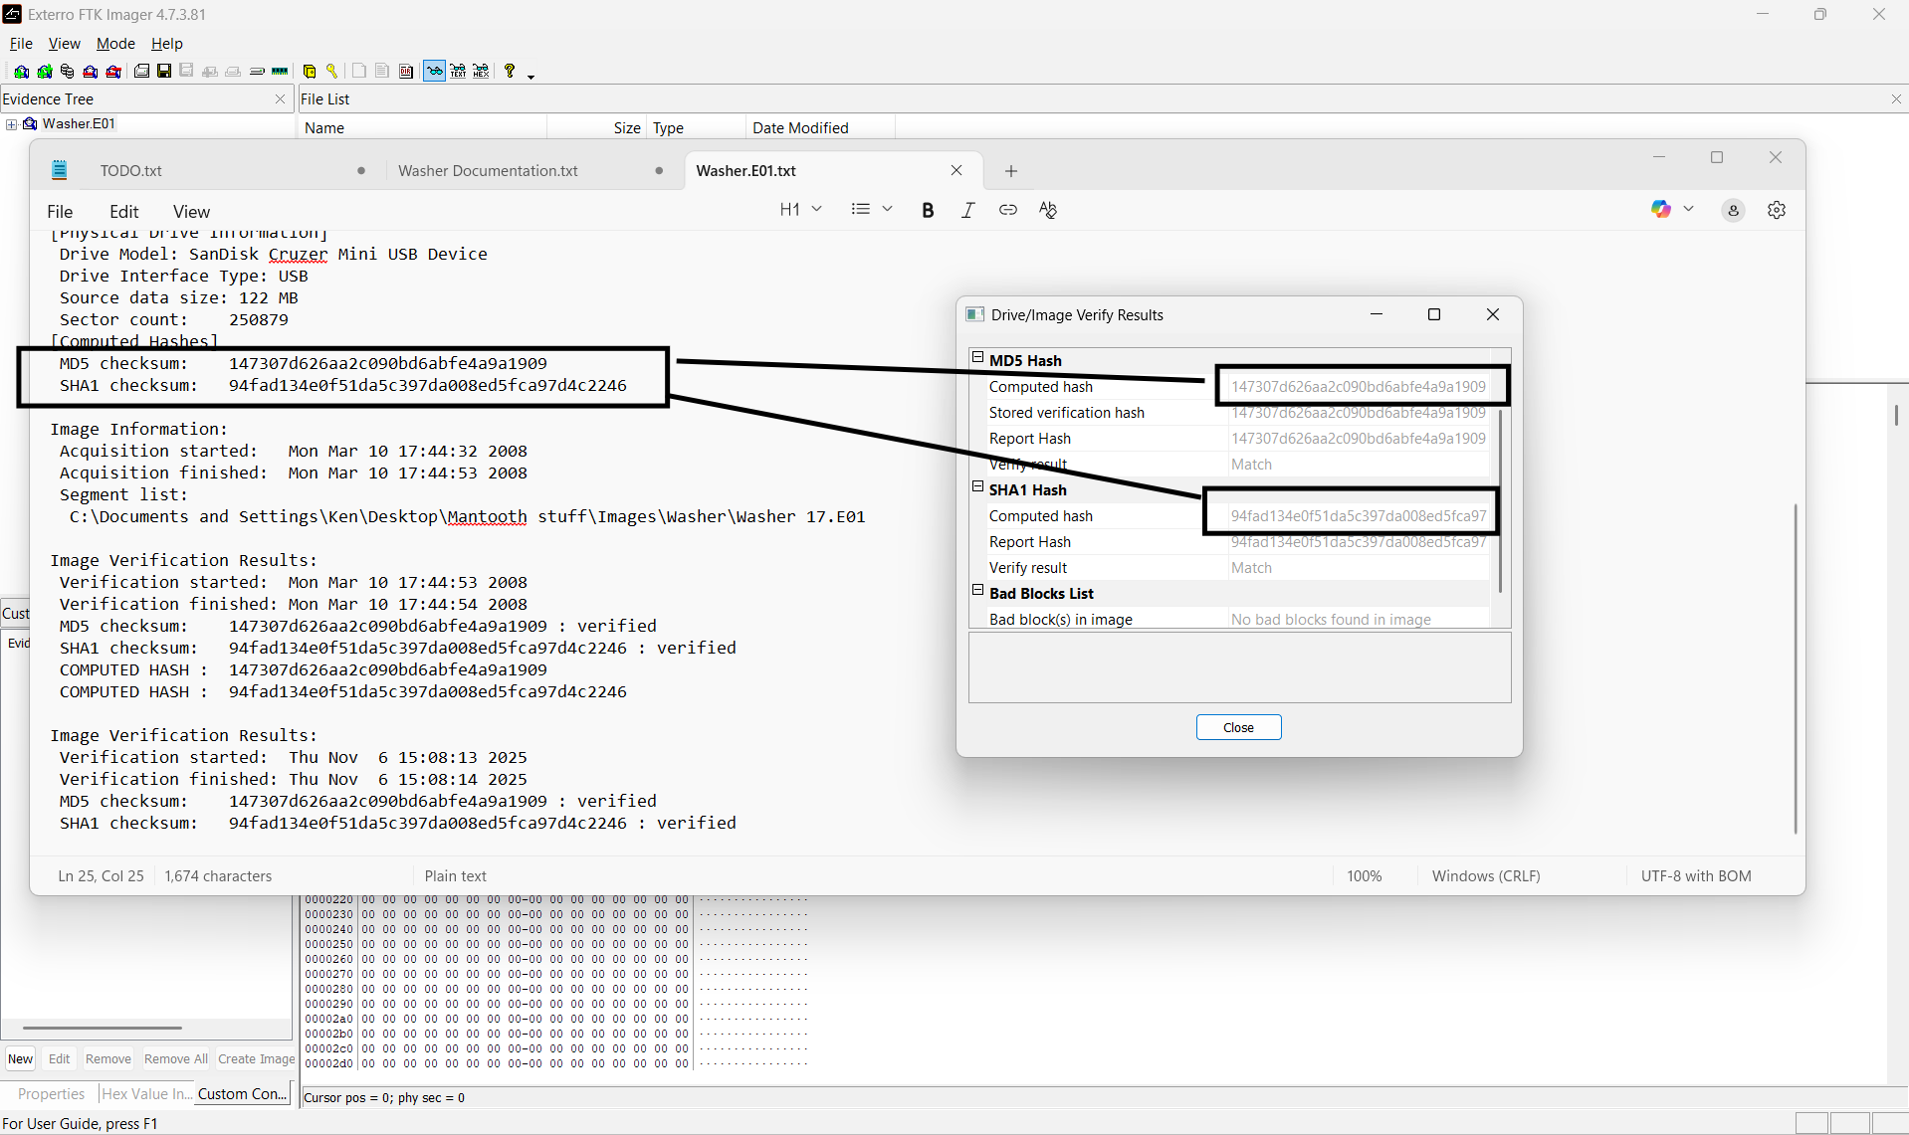
Figure 1: SHA1 & MD5 hash for the Washer image file.
Then at 8:32 P.M. UTC, I loaded the Washer.E01 image file into the digital forensics tool Autopsy. I determined that the next steps I should take are determining what operating system this device uses as well as who the owner of this device is. At 8:35 P.M. UTC, I clicked on Operating System Information in the left-hand pane of Autopsy. I found that the owner and main user of this device is named John Washer, and the operating system on this device is Microsoft Windows XP, shown in Figure 2.
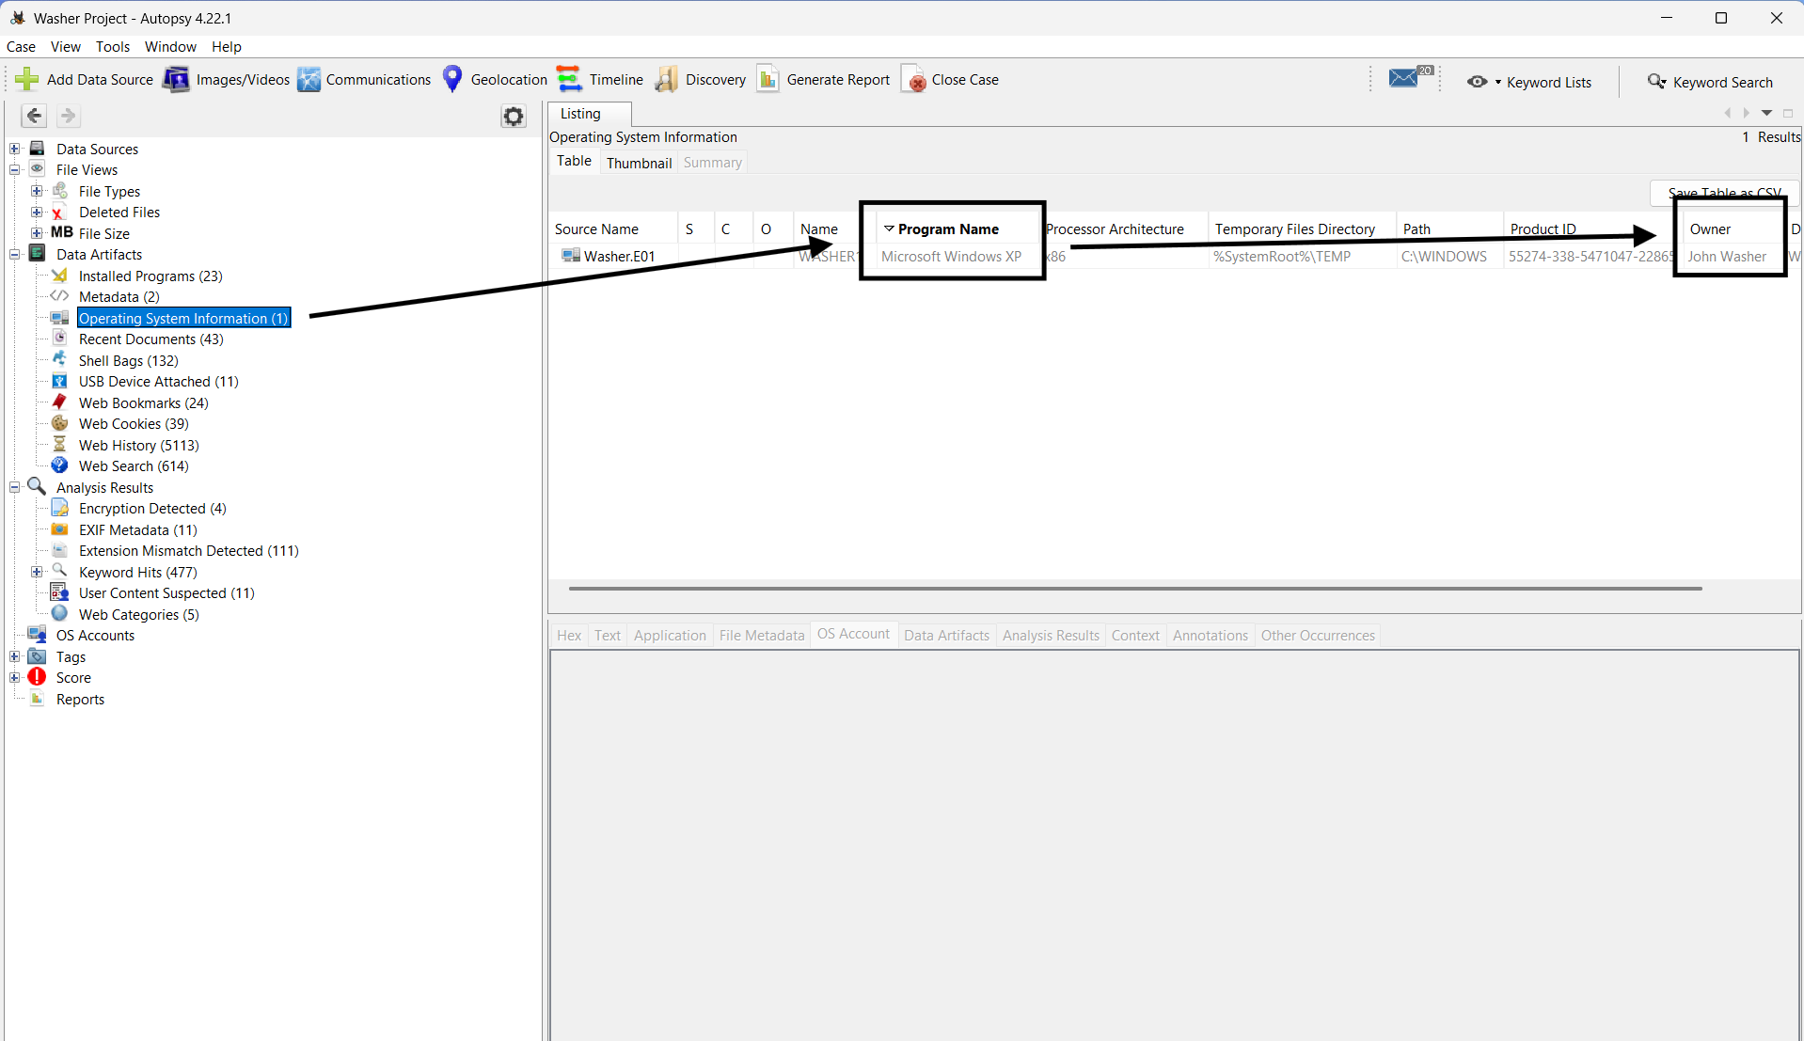
Figure 2: Operating System and Owner of the Washer device.
Now that I verified the integrity of the Washer.E01 file and learned more about the device, I will talk about the evidence that I found during my investigation. On 11/12/2025 at 8:52 P.M. UTC, I located a Google search for “how to steal checks.” A picture of this search can be seen in Figure 3. While it is not illegal to search for this information, it raises some red flags about what John Washer is doing with his free time. After locating the search, I began searching for evidence that proves John Washer is involved in stealing others' financial information.
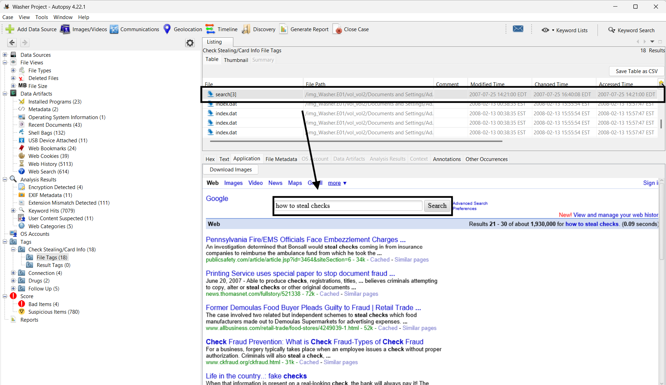
Figure 3: A suspicious Google search
Following finding this Google search, I decided to run a keyword search for “checks” at 9:19 P.M. UTC. I found that the user visited a website on check washing, which is a way that you can steal checks from people and replace the recipient information with your own. Figure 4 shows a screenshot of this website. Again, I will mention that it is not illegal to visit this website, but it raises even more concerns that John Washer is visiting these websites.
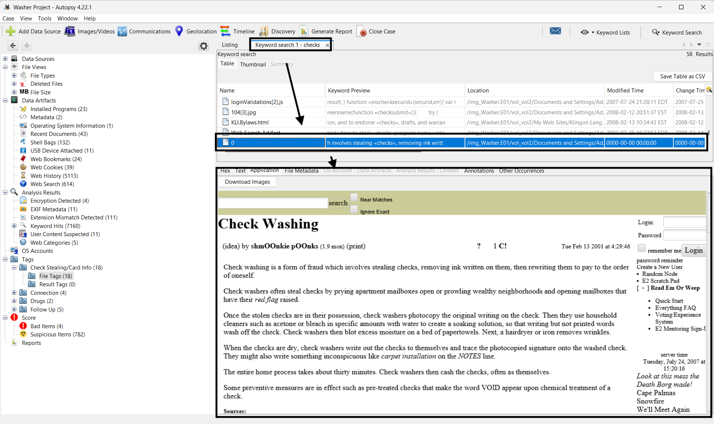
Figure 4: A website on check washing.
In my search for evidence of stealing financial information, I discovered four different password-protected files that might have some relation to Washer stealing checks and check washing. Figure 5 shows a screenshot of the four files that I found on 11/6/2025 at 8:50 P.M. UTC. Later in this report, I will dive further into those password-protected files, but now I will turn my focus towards the evidence I found about John Washer and the use, distribution, and making of drugs.
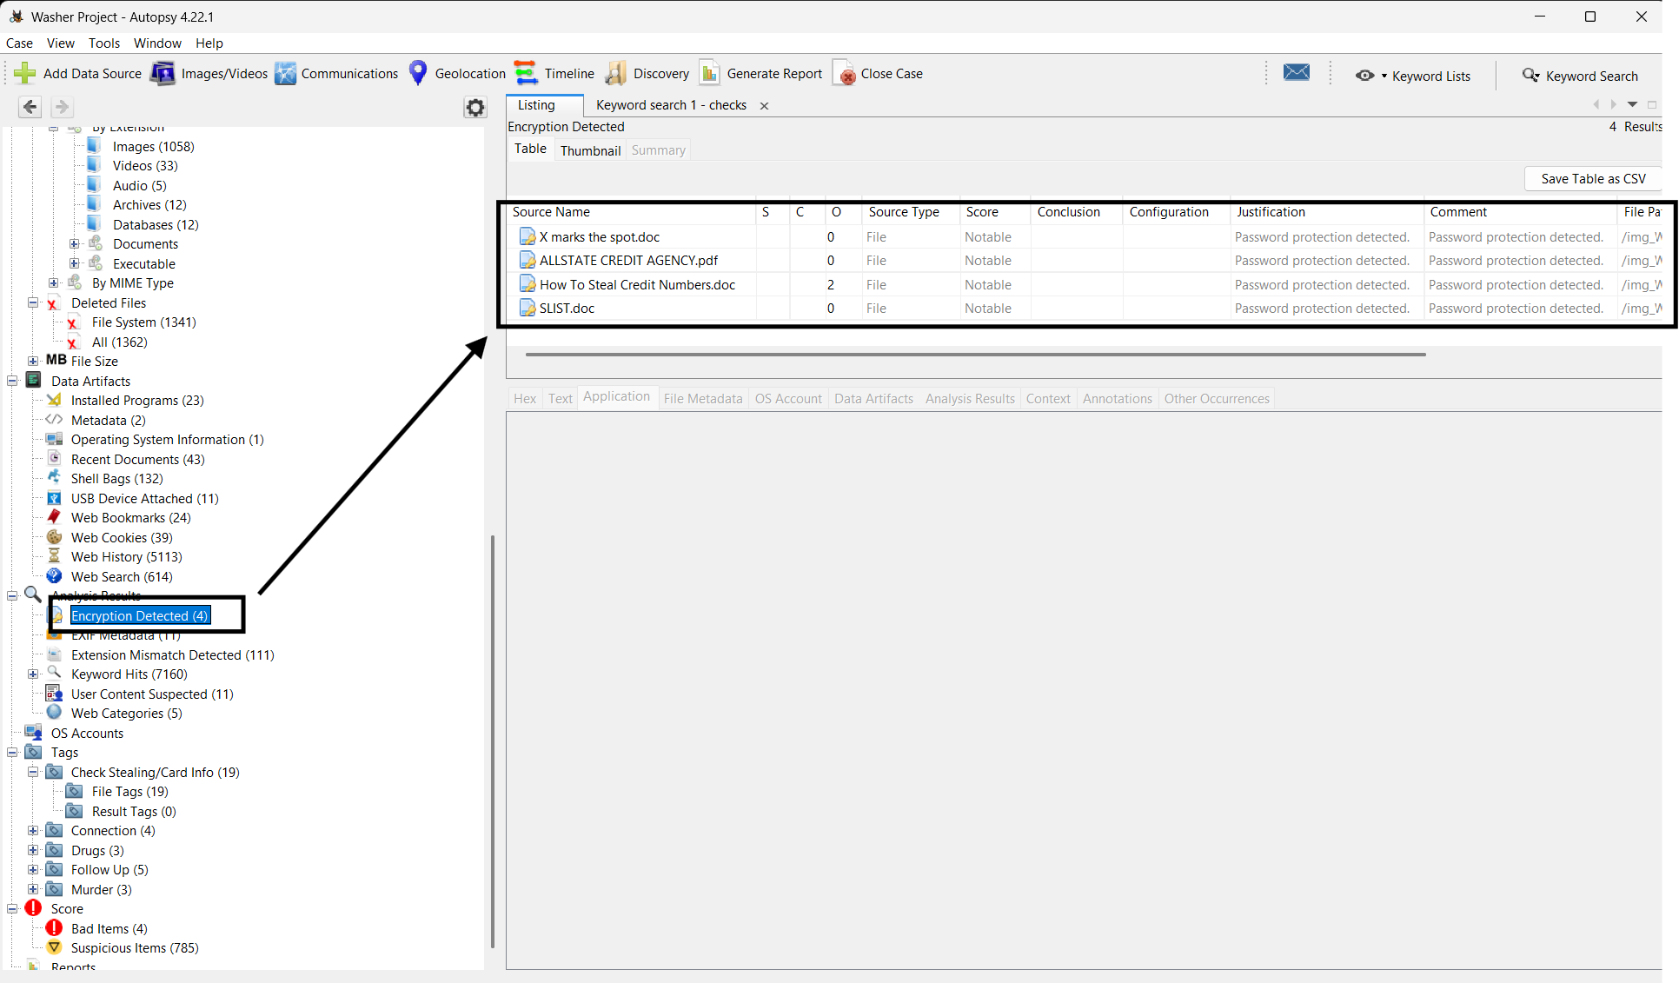
Figure 5: Password-protected files
I was able to locate three different items of evidence involving drugs and John Washer. I found the first item at 9:12 P.M. UTC on 11/12/2025, it is a deleted as well as a sent e-mail from Washer to Mantooth about Special K, which is a common reference to drugs. A screenshot of these files can be seen in Figure 10.
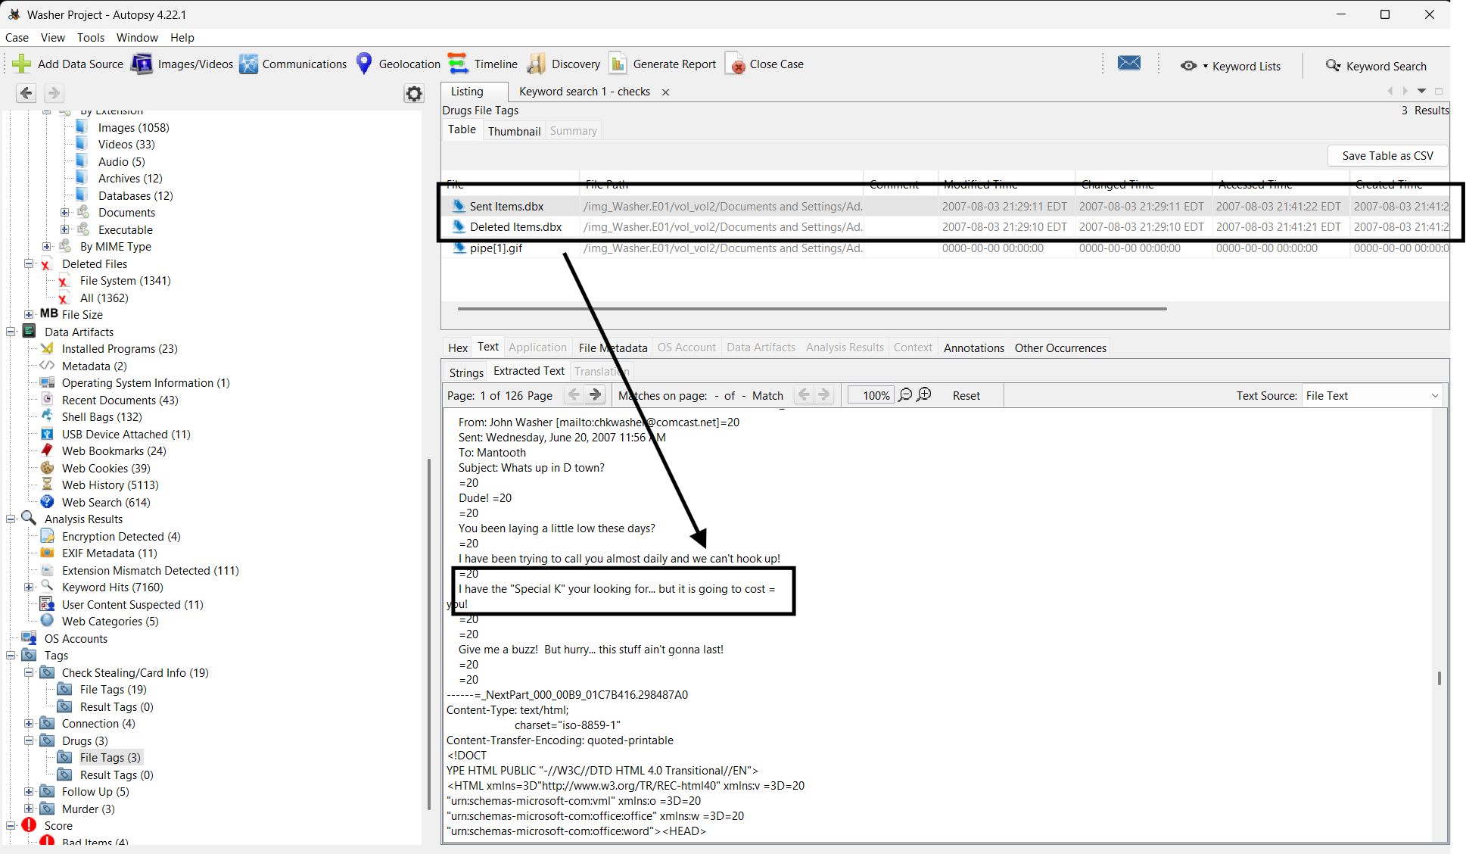
Figure 6: Special K e-mail
The next piece of evidence I found is a deleted image titled pipe[1].jpg. I found this at 10:32 P.M. UTC on 11/12/2025. This image could not be extracted because it was most likely overwritten, but this image could be of a meth pipe based on the title of the file. The deleted file can be seen on Figure 11.
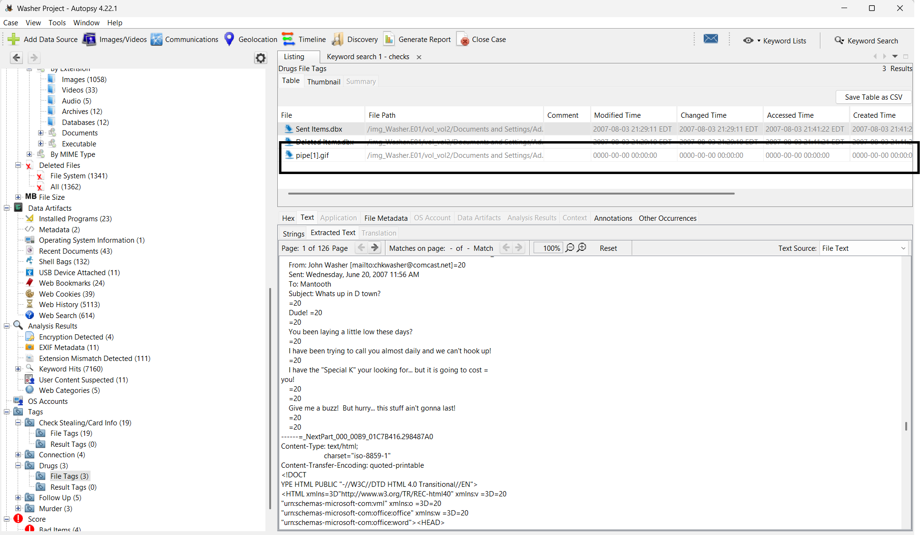
Figure 7: Deleted Image
At 9:08 P.M. UTC on 11//6/2025, I found a chat log between Washergonebad (John Washer) and rbadguy2424 (Rasco Badguy) which contained passwords and references to drugs. The chatlog can be seen in Figure 8, where Rasco is telling Washer he is making meth. I will keep a list of the passwords that they discussed, just in case I can use them in the future.
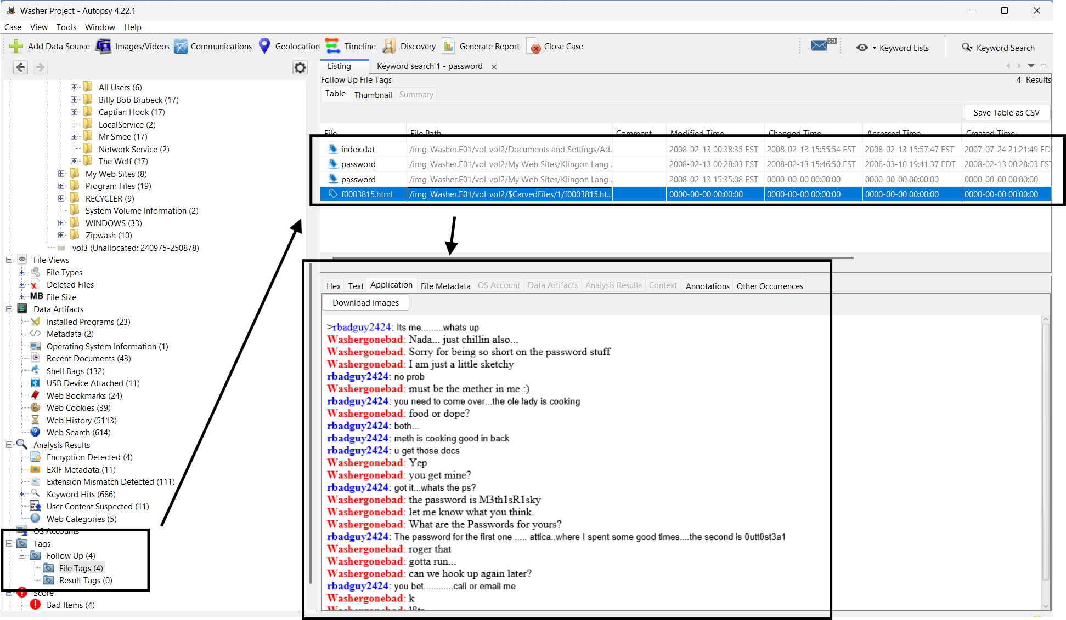
Figure 8: Chat Log
There was one other file that I found which interested me. At 10:55 P.M. UTC on 11/12/2025, I found that the user made a search for “hiding a body” which can be seen on Figure 9. This was the only piece of evidence I located regarding a possible homicide, but it is still concerning and should be followed up on.
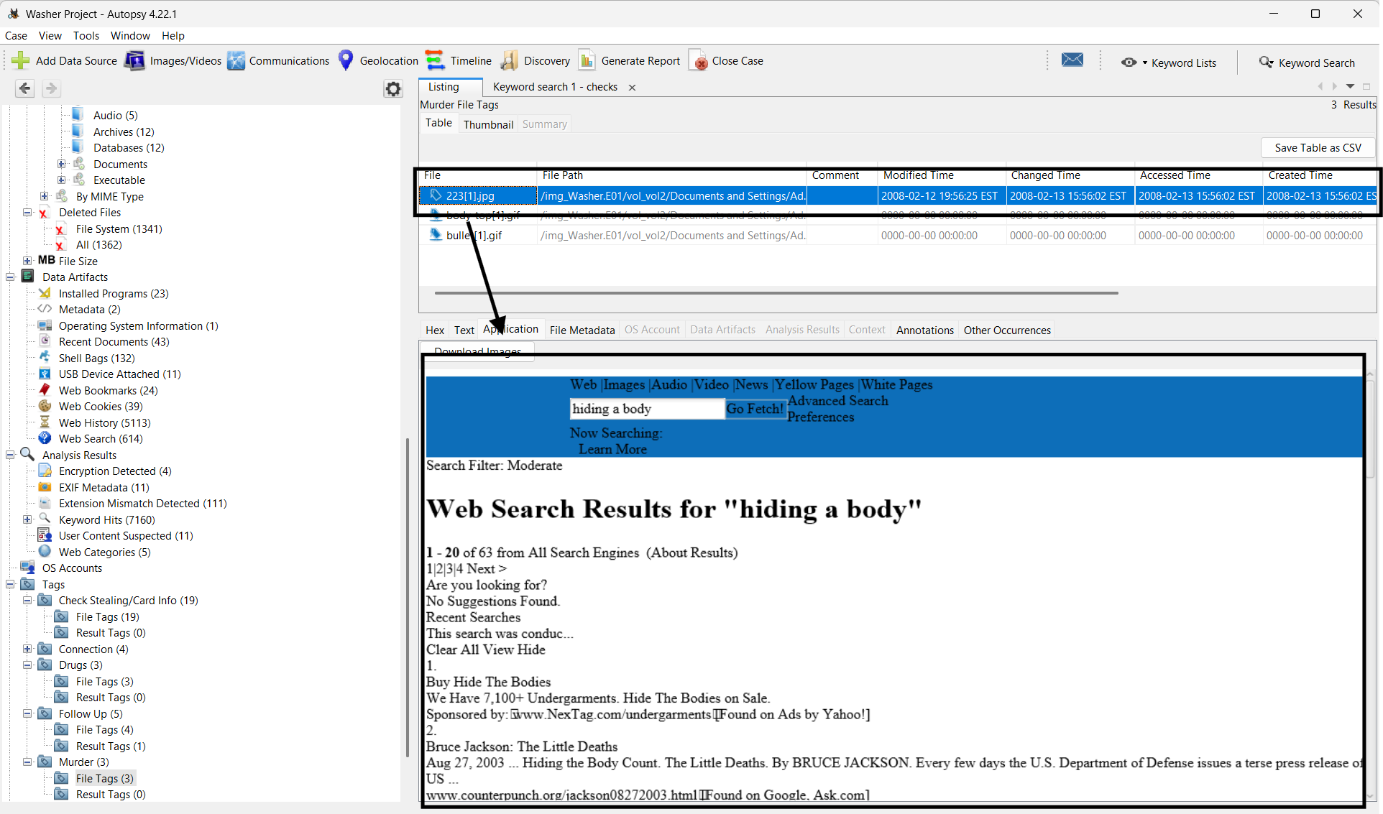
Figure 9: Suspicious Search
  - Password-Protected Files
On 11/6/2025 at 8:50 P.M. UTC, I located four different password-protected files; refer to Figure 5 to see a screenshot of the files. In this section of my report, I will attempt to find the passwords to see the contents of the file. I will start with the file “How to Steal Credit Card Numbers.doc.” If you refer back to Figure 8, you can see in the chat logs that John Washer and Rasco Badguy were talking about some passwords, so I will try those and see if any give me access. The password 0utt0st3a1 worked for the file “How to Steal Credit Numbers.doc” and the contents can be seen in Figure 10. This document proves to be even more evidence that John Washer is involved in some stealing others' financial information.
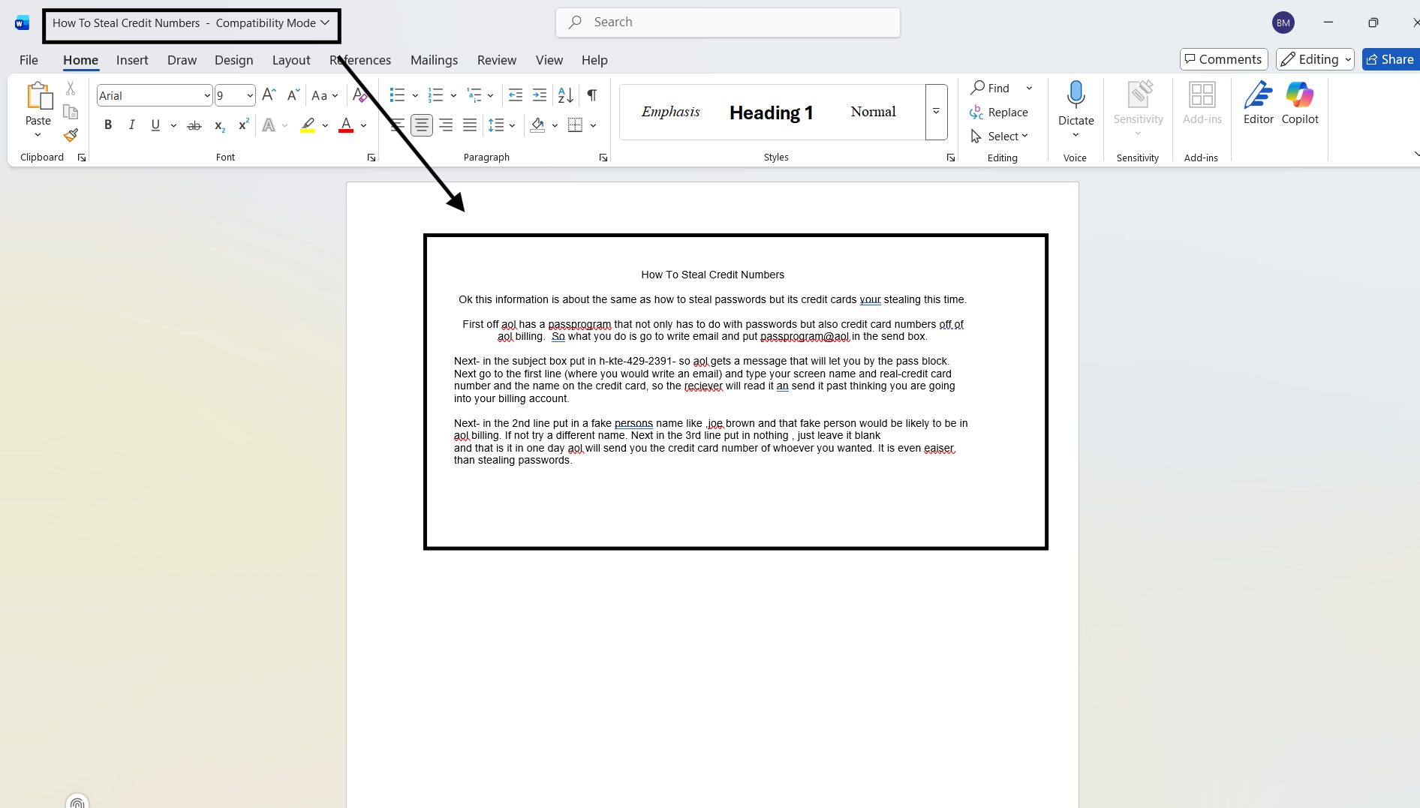
Figure 10: Contents of password-protected file.
Next, I attempted to open “ALLSTATE CREDIT AGENCY.pdf” and “X marks the spot.doc” using the other passwords in the chat log, but they did not work. Then, at 10:58 PM UTC on 11/6/2025, I attempted to open “SLIST.doc,” and it needed a password to modify the file, but not to view the file. The contents of “SLIST.doc” can be seen in Figure 11. It appears to be a list of different credit card numbers, the CVV, and the expiration date. This file, as well as the other evidence that I was able to gather, leads me to believe that the contents of this file are card numbers that have been stolen.
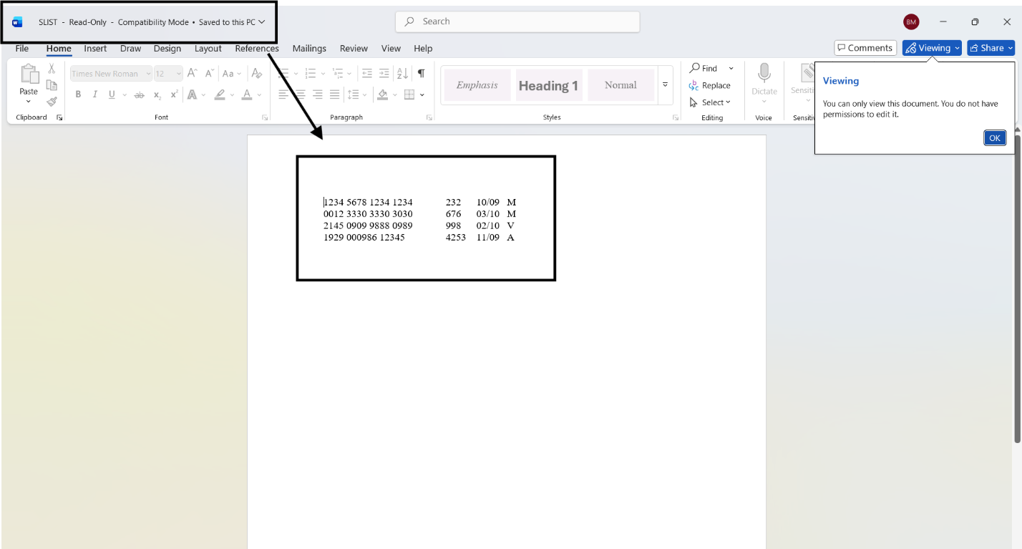
Figure 11: Stolen card information
  - Relation to Mantooth
In this section of my report, I will talk about any evidence tying John Washer to Wes Mantooth. First, I will begin by talking about the Mantooth Case. I found that Mantooth had evidence of stealing financial information and doing, making, or distributing drugs, which is the same evidence I found for Washer. I also found information in the Mantooth case, as well as the Washer case, that John Washer, Wes Mantooth, and Rasco Badguy have been in contact. The email messages between them were found at 4:22 P.M. UTC on 11/13/20255, and can be seen in Figure 12.
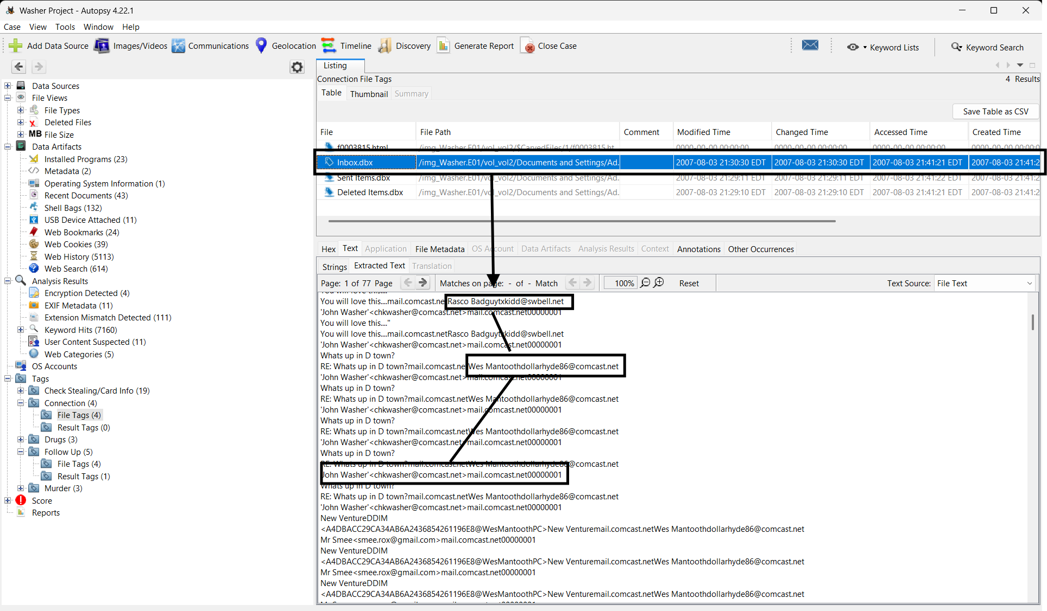
Figure 12: Conversation between Washer, Mantooth, and Badguy.
- Conclusion
  - Story
The story for this user is very interesting. I found lots of evidence that John Washer is involved in illegal activities, such as consuming, manufacturing, and or selling drugs, as well as stealing credit card information. I also found a suspicious search for “how to hide a body” that might suggest he has to hide a body. Based on John Washer's multiple suspicious searches and all of the other evidence I presented earlier in this report, I suspect John Washer has been working with Wes Mantooth and Rasco Badguy to steal financial information from others, and consuming and making drugs, specifically methamphetamine.

  - Timeline
Object | Open or Installed (UTC) | Significance
How to Steal Credit Card Numbers.doc | 2007-07-25 16:08.36 | This is a password-protected document that talks about how someone can steal credit card numbers.
SLIST.doc | 2007-7-25 16:08.32 | This is a password-protected document that has a list of stolen credit card numbers.
Google search – how to steal checks | 2007-7-25 14:21.00 | This is a Google search on how a person can steal checks. Washer could have gotten the How to Steal Credit Card Numbers.doc from this search.
Mantooth, Washer, and Badguy emails | 2007-08-03 21:29.10 | This is an email chain between Mantooth, Washer, and Badguy, proving that they have had some previous connection.

  - Concluding Statement
In summary, the forensic examination of the *Washer.E01* image yields abundant digital evidence pointing to John Washer's involvement in a string of illicit activities such as credit card theft, check fraud, and drug dealing. The artifacts that were recovered, including incriminating documents, chat logs, and suspicious searches, strongly indicate a structured criminal activity by Washer, Wes Mantooth, and Rasco Badguy. Further corroboration is proven by the fact that the data recovered in this case matches evidence from the Mantooth case, further establishing the evidence against these three individuals as members of an organized operation. All evidence was extracted by using forensically sound procedures; therefore, it is reliable and admissible. It is recommended that law enforcement further investigates these associations, as strong evidence points towards an active criminal conspiracy which may pose a threat to citizens.

